Chapter 17, Problem 9.

Determine the Fourier coefficients a_{n} and b_{n} of the first three harmonic terms of the rectified cosine wave in Fig. 17.52.

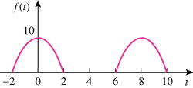

Figure 17.52
For Prob. 17.9.

